Joint Angles Operators Analysis

There are some key factors that we will look at with the averages of the data provided for joint angles and whether or not they were within or outside the +20 to -20 degree threshold set by the Noraxon software. We can also look at the sum of duration within these points to reference that as well. If you have any questions or would like me to change the graphs in any way, I can do that and help answer what I found from the data.

It appears that we see higher amounts of above or below threshold risk when looking at the Cervical/Thoracic compared to the Lumbar/Pelvic positions of the joints.

Also, I want to note that for subject 1, I averaged 3.1,3.2 and 6.1,6.2 respectively to make them just case 3 and case 6.

# Sum of Duration Thresholds

* First, we are assessing the values that are above the threshold.
* 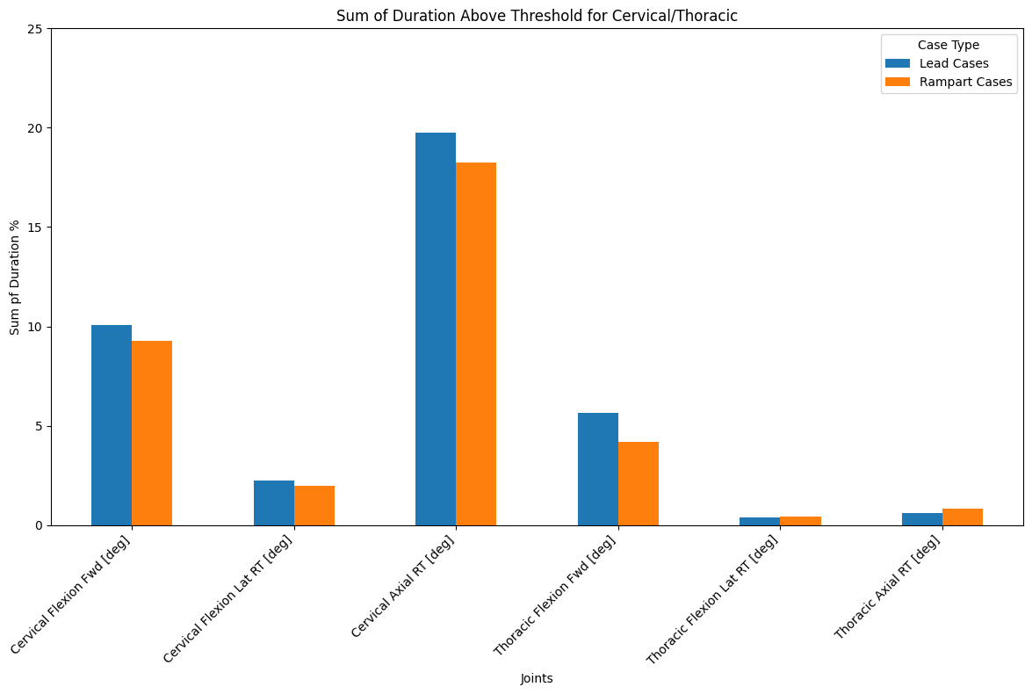
  + Initially, Cervical Axial appears to be the highest. We also see that the cervical flexion forward is high. This could be due to watching the screens.
* 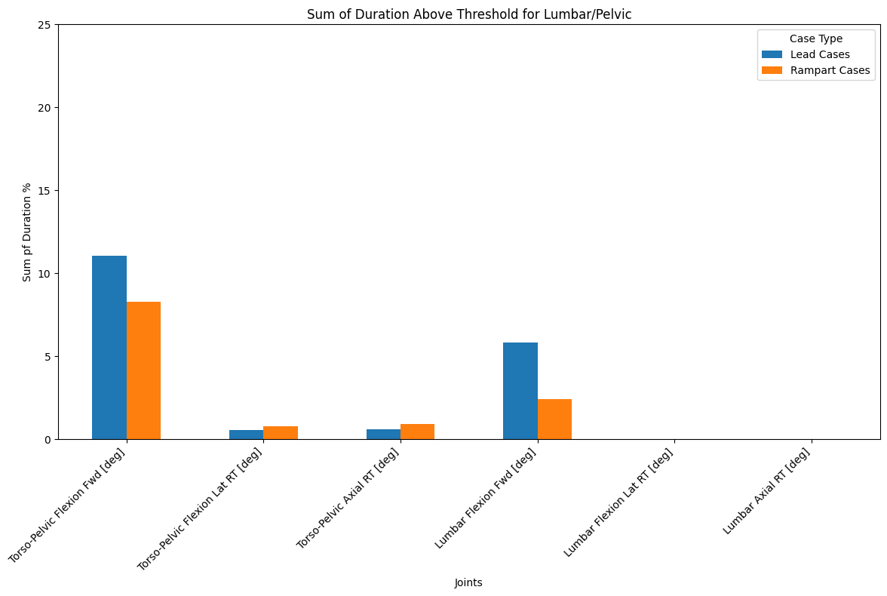
  + We initially see that the lumbar/pelvic values have less of an amount of duration above thresholds.
* Now, assess the sum of duration inside the threshold.
* 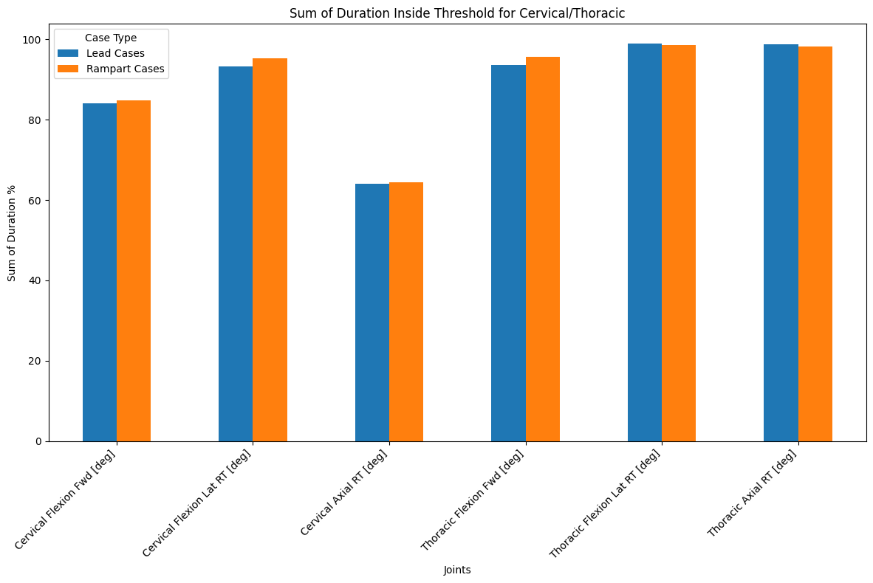
  + As we saw earlier, cervical axial has less time spent within the safe threshold compared to all other joints. Cervical flexion forward also sees some similar results.
* 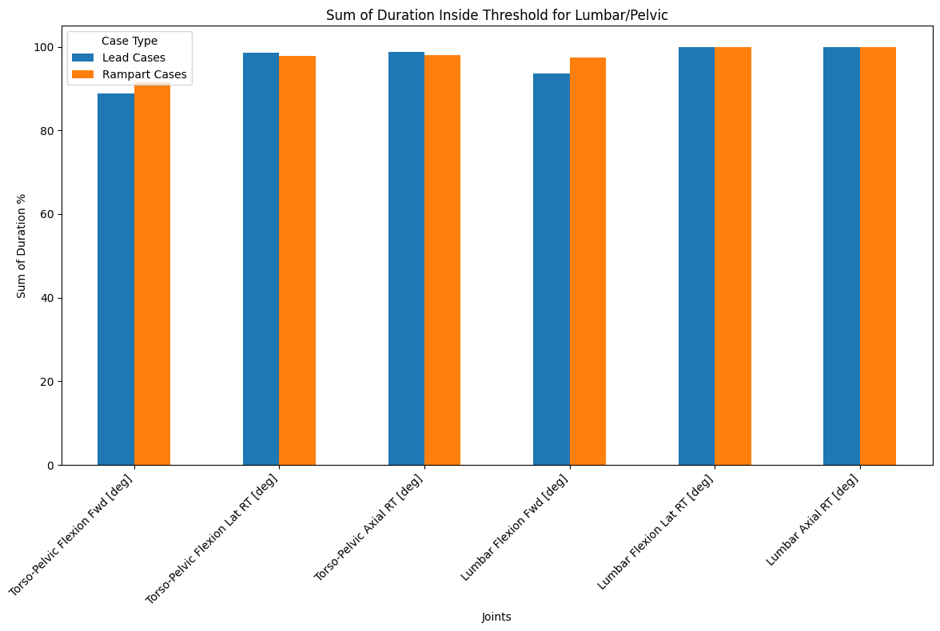
  + Once again, we see that the values appear to have stayed within safe thresholds about 90% of the time and above.
* Now assess the average duration below threshold.
* 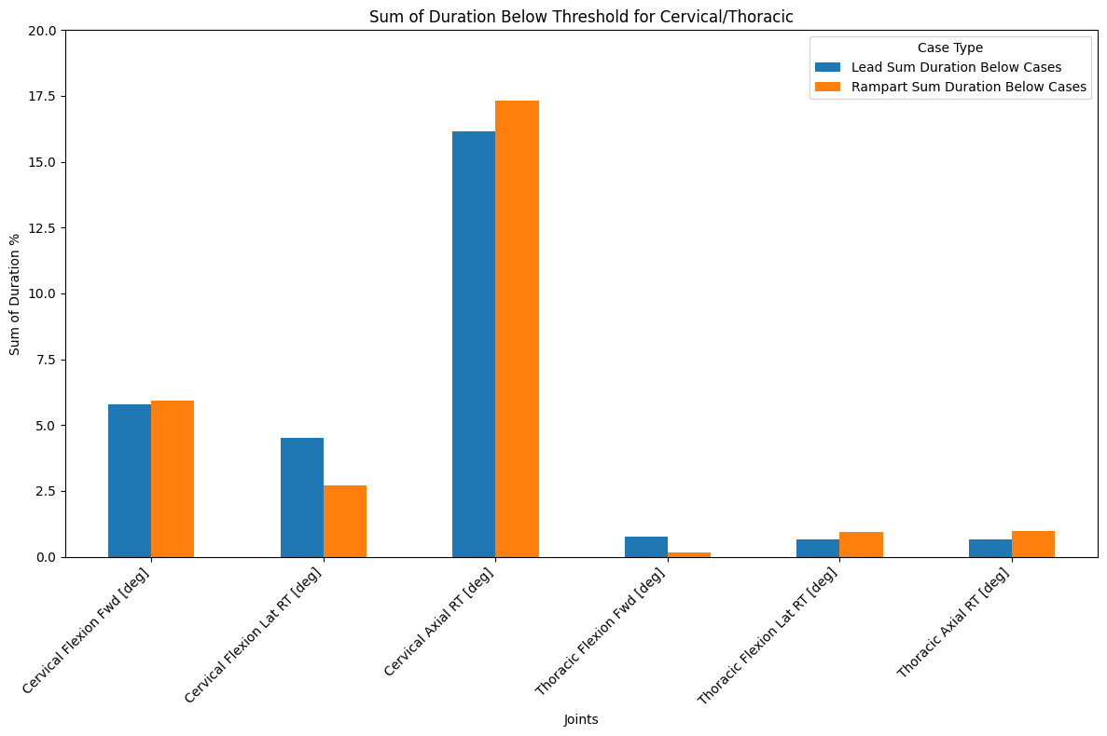
  + Here, we see similar results as to the above threshold values, which makes sense. There appears to be slightly higher percentages above threshold generally. That could be indicative of more rightward turning of the head.
* 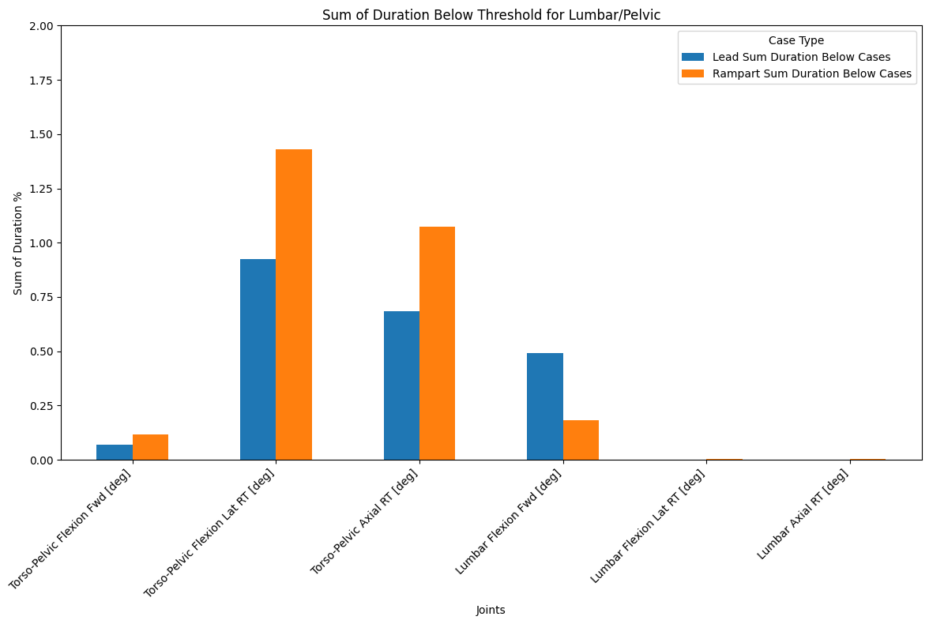
  + These values were really small, so I changed the y-axis to going up to only 2 percent to see some of the difference.

# Stratifying the Data

* Here I attempted multiple techniques of grouping the data. I looked at the gender, cases, attending vs. non-attending, age, height, weight, and exercise status.
* I combined the above and below durations into one labeled Risk Threshold. I can change the nomenclature if you want, but here are the respective graphs.
* I can also split up the resulting plots into a large single plot and change the axis titles. I just wanted to make it so that it would be easy to see the differences all on one plot by the various categories of stratification that we developed.
* First, assessing gender:
  + 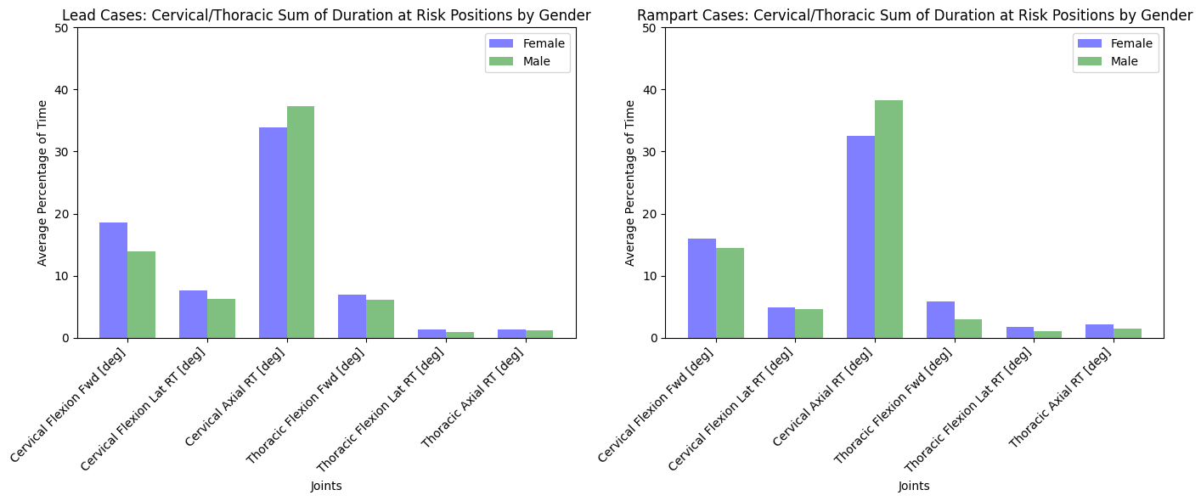
    - Generally, the males here were at higher risk positions for the cervical axial longer, while the females were within risk thresholds for longer durations everywhere else.
  + 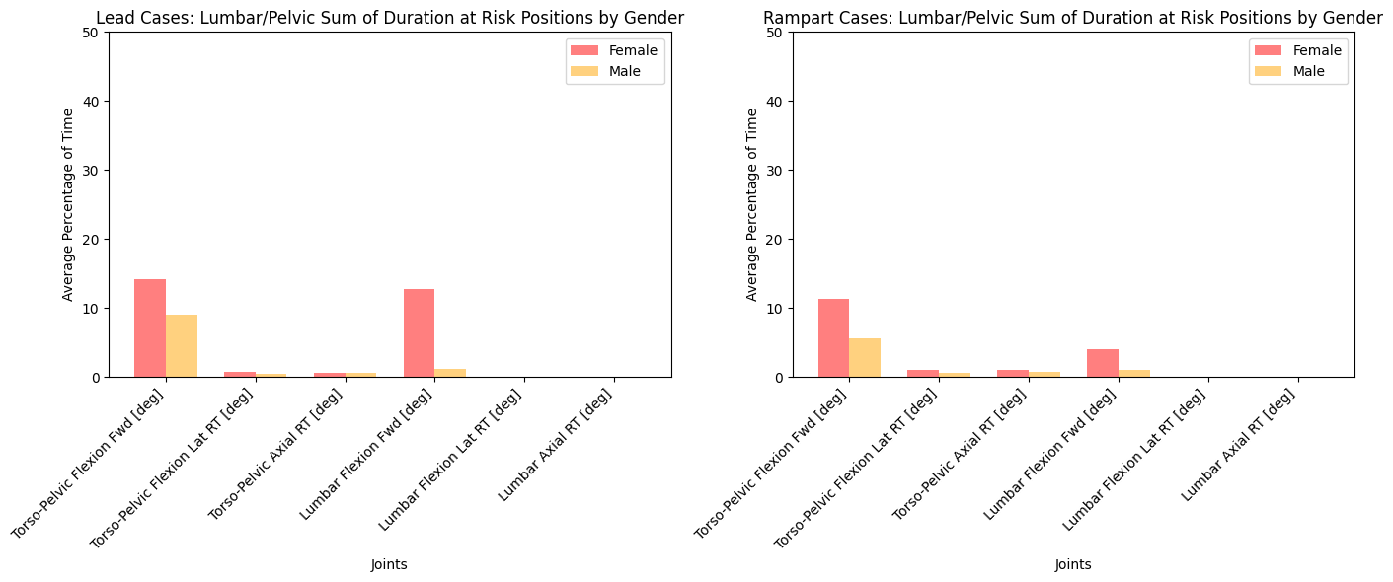
* Now assessing cases:
  + I didn’t have data that applied to every case for individuals, but I thought I would display specifically what we did have and not have data for all in one for you to decide from what to keep.
  + 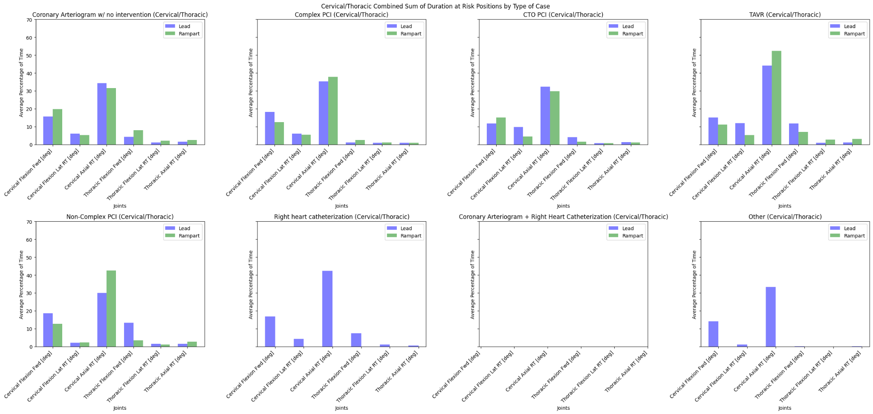
    - This is hard to see but it was intneresting how the lead and rampart had very different outcomes based on the case. This could also be due to the individuals as confounding variables per case given that the data would be very small for each case.
  + 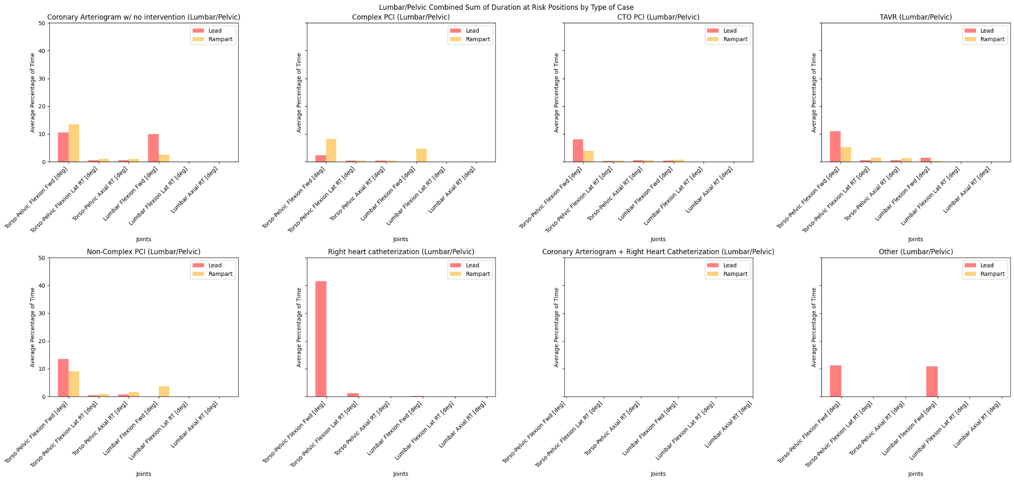
* Assessing Roles in Cath Lab:
  + 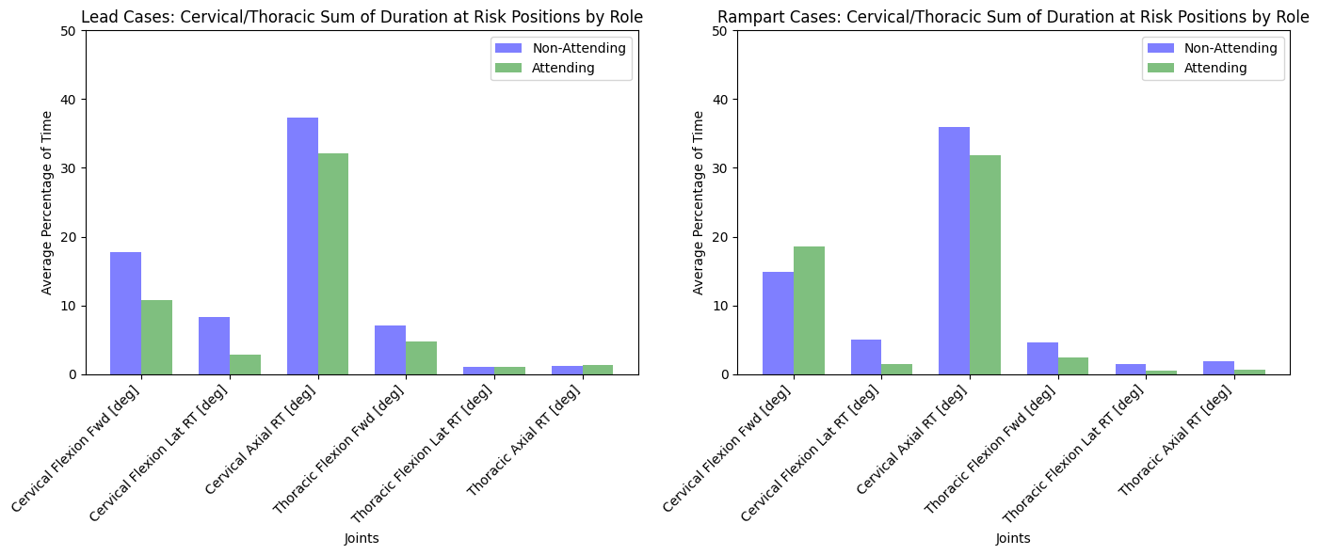
    - It appears that the non-attending individuals clearly spent more time in a risk threshold compared to the attending individuals.
  + 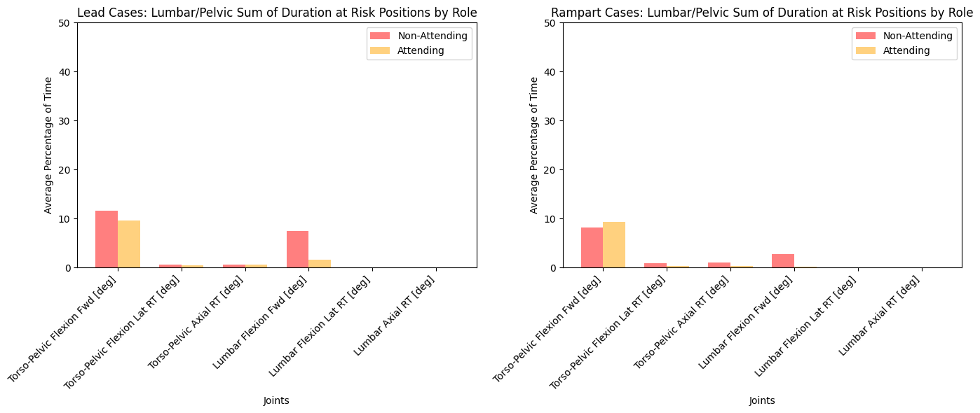
* Assessing Age Groups:
  + 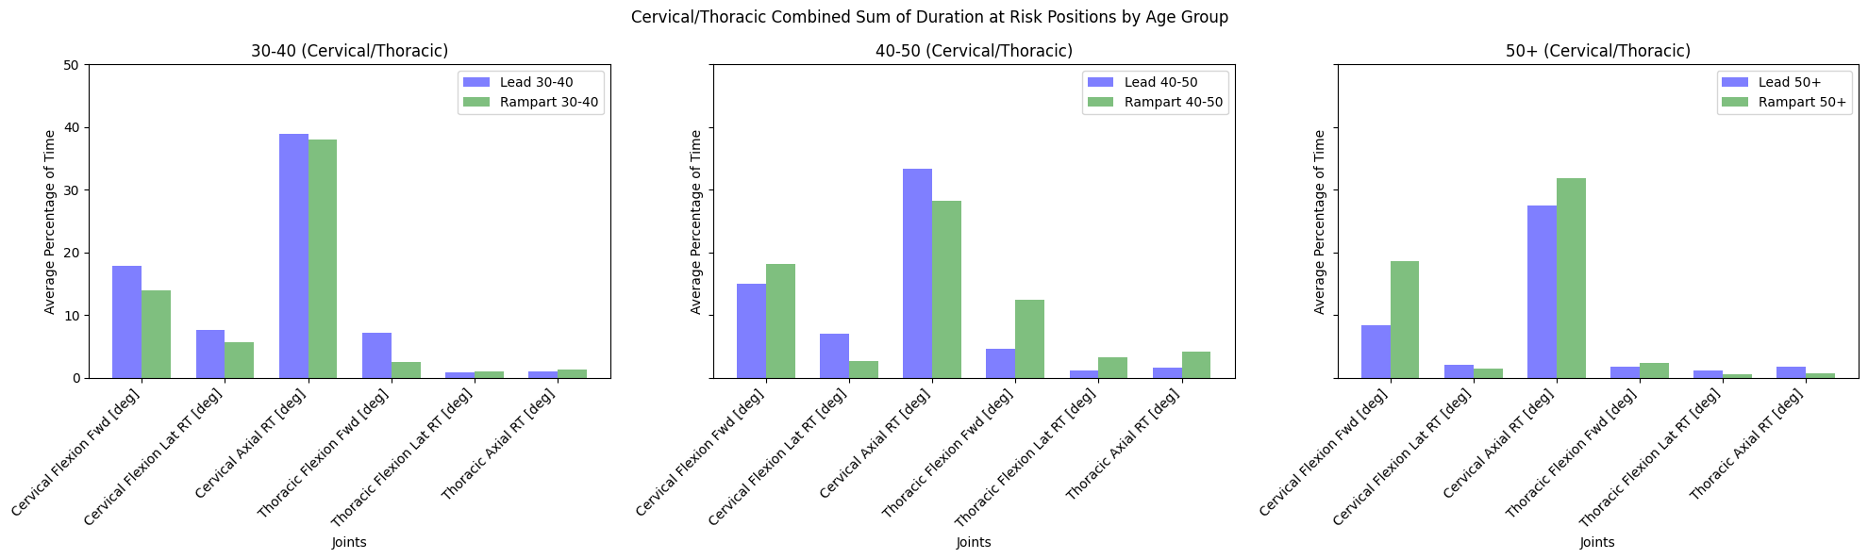
    - Here there wasn’t too much to gather from the data. You can maybe see a slight decrease in the cervical/thoracic areas as a person gets older.
  + 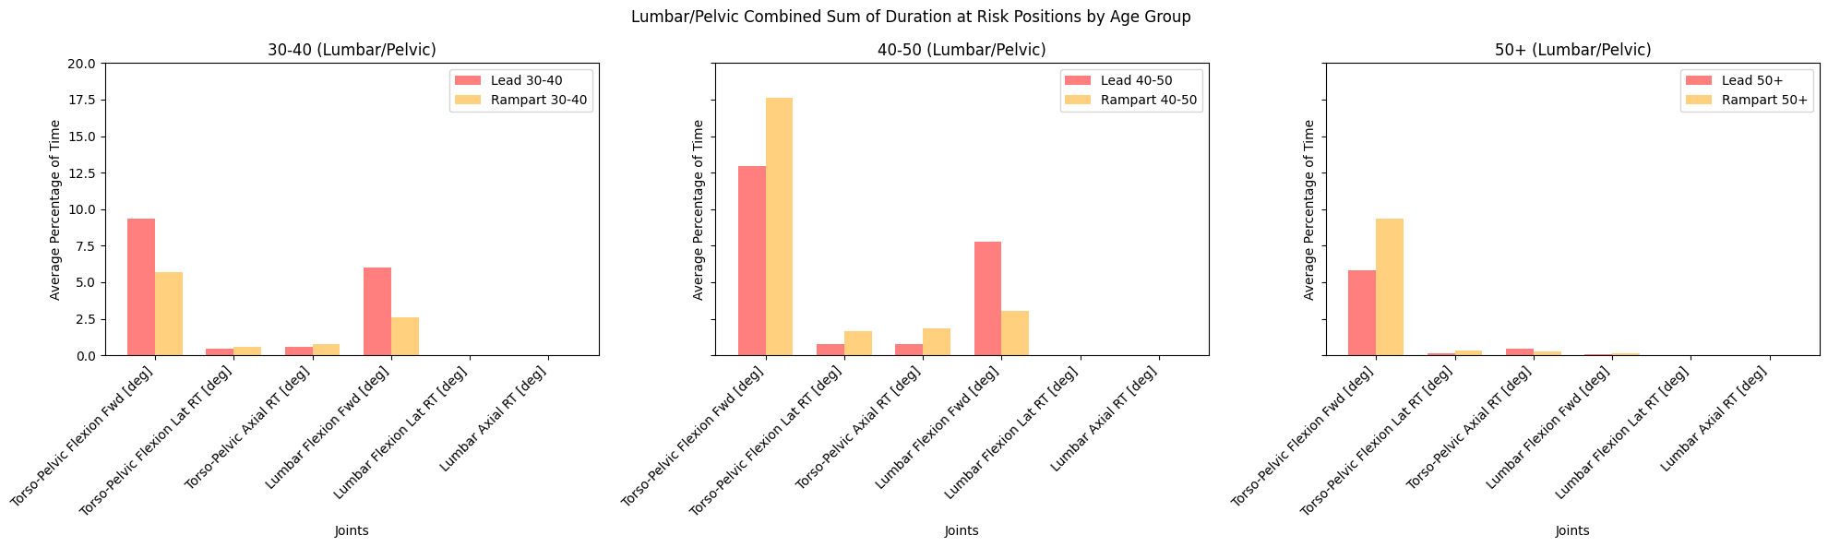
* Assessing weight classes:
  + 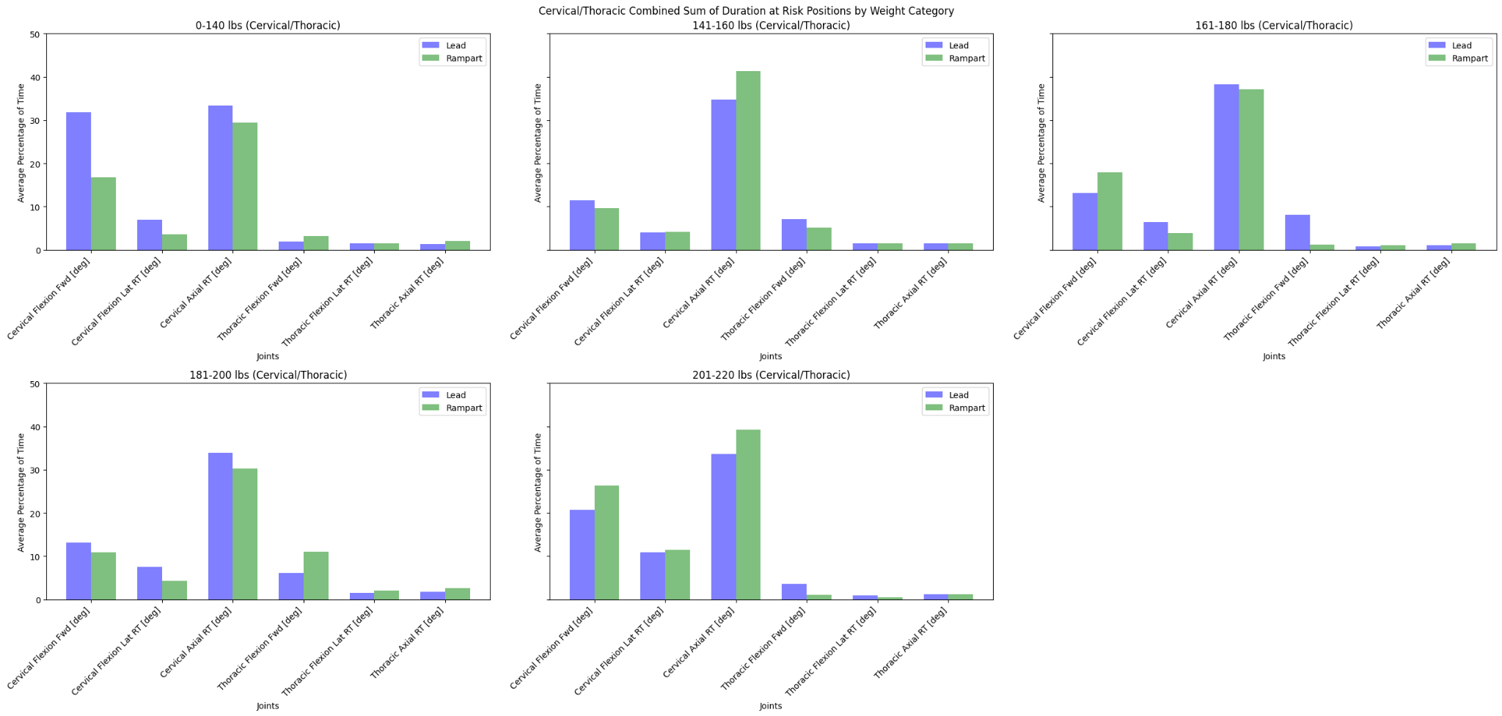
  + 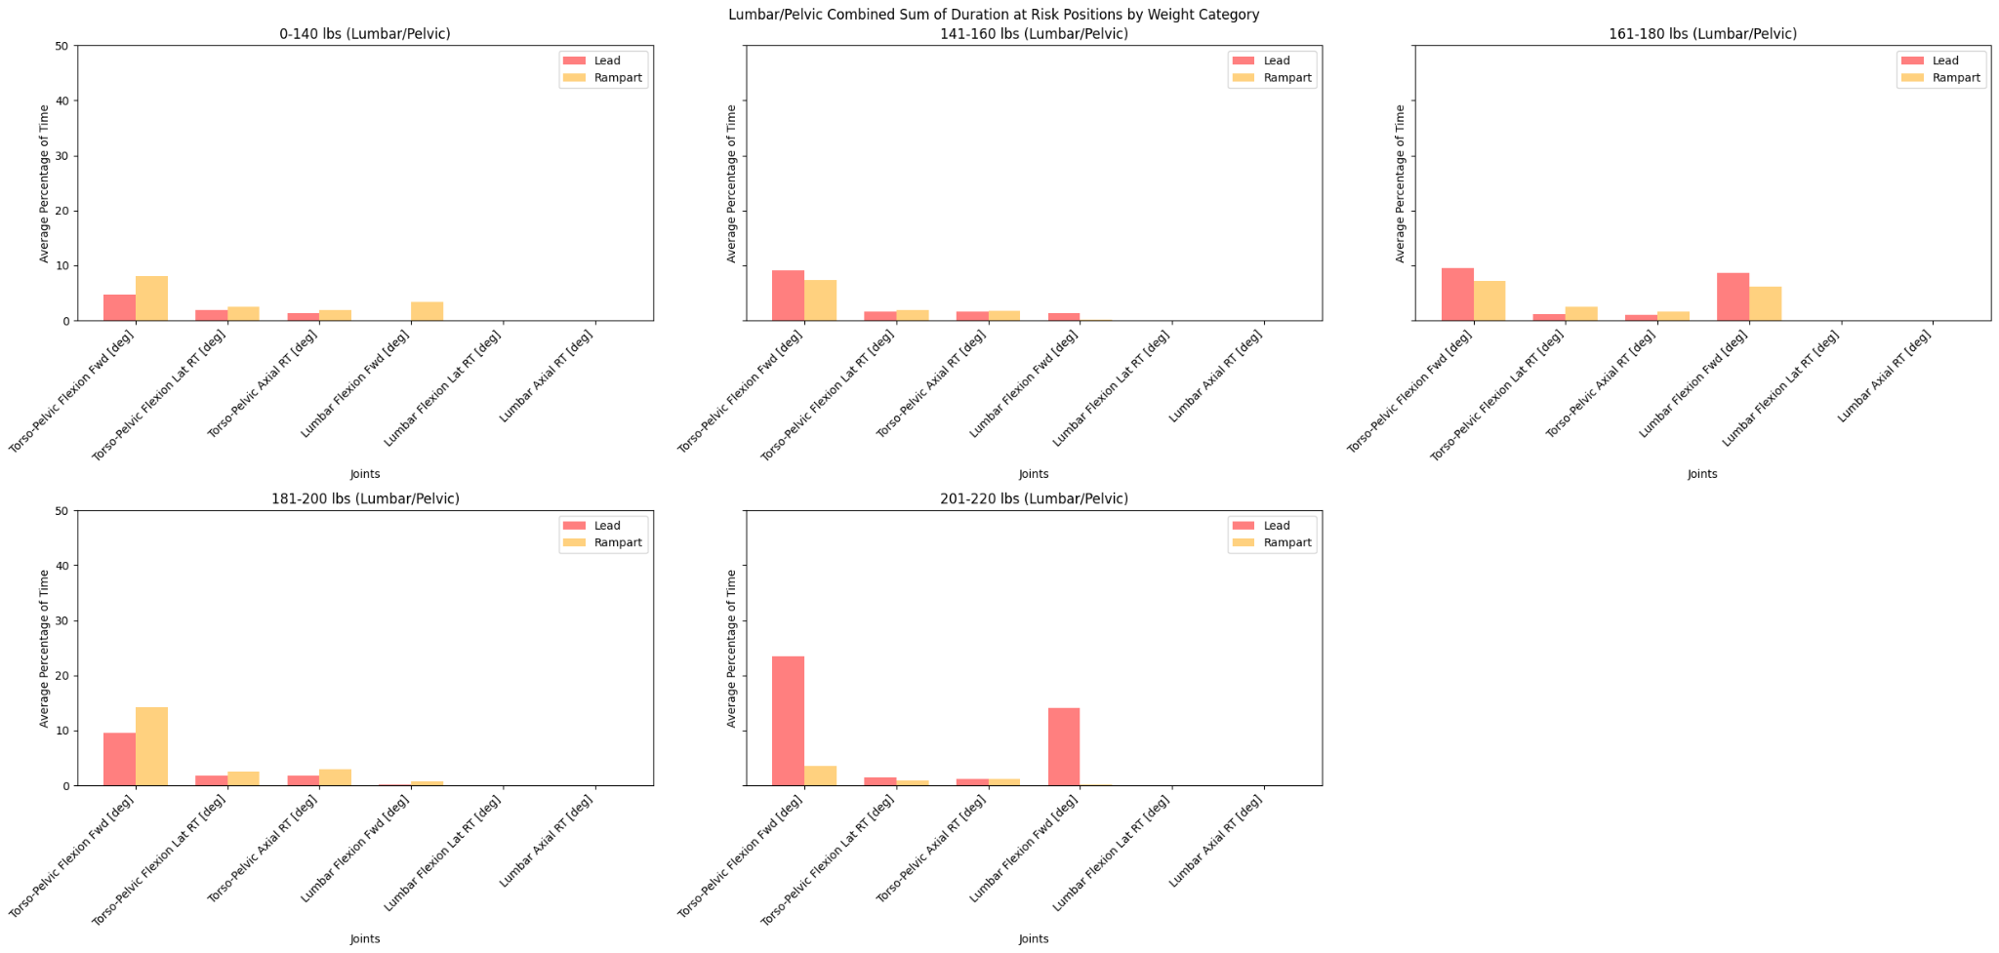
* Assessing Height:
  + 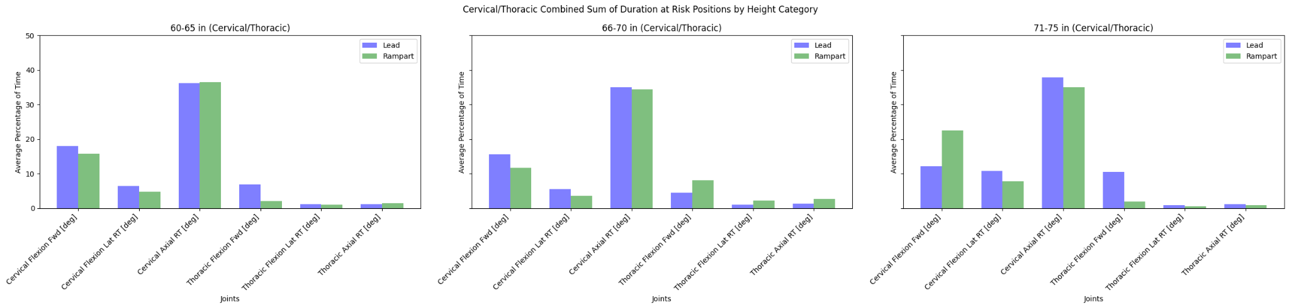
  + 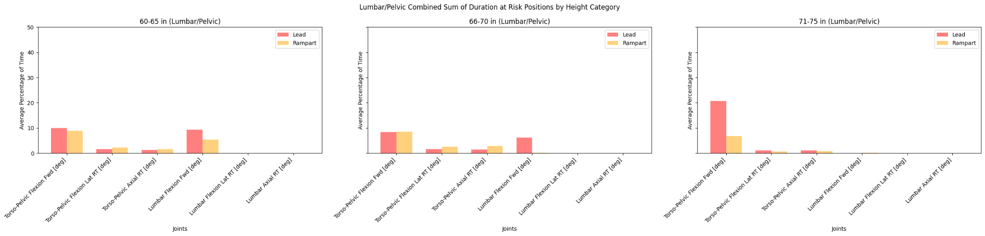
* Assessing Exercise Status:
  + 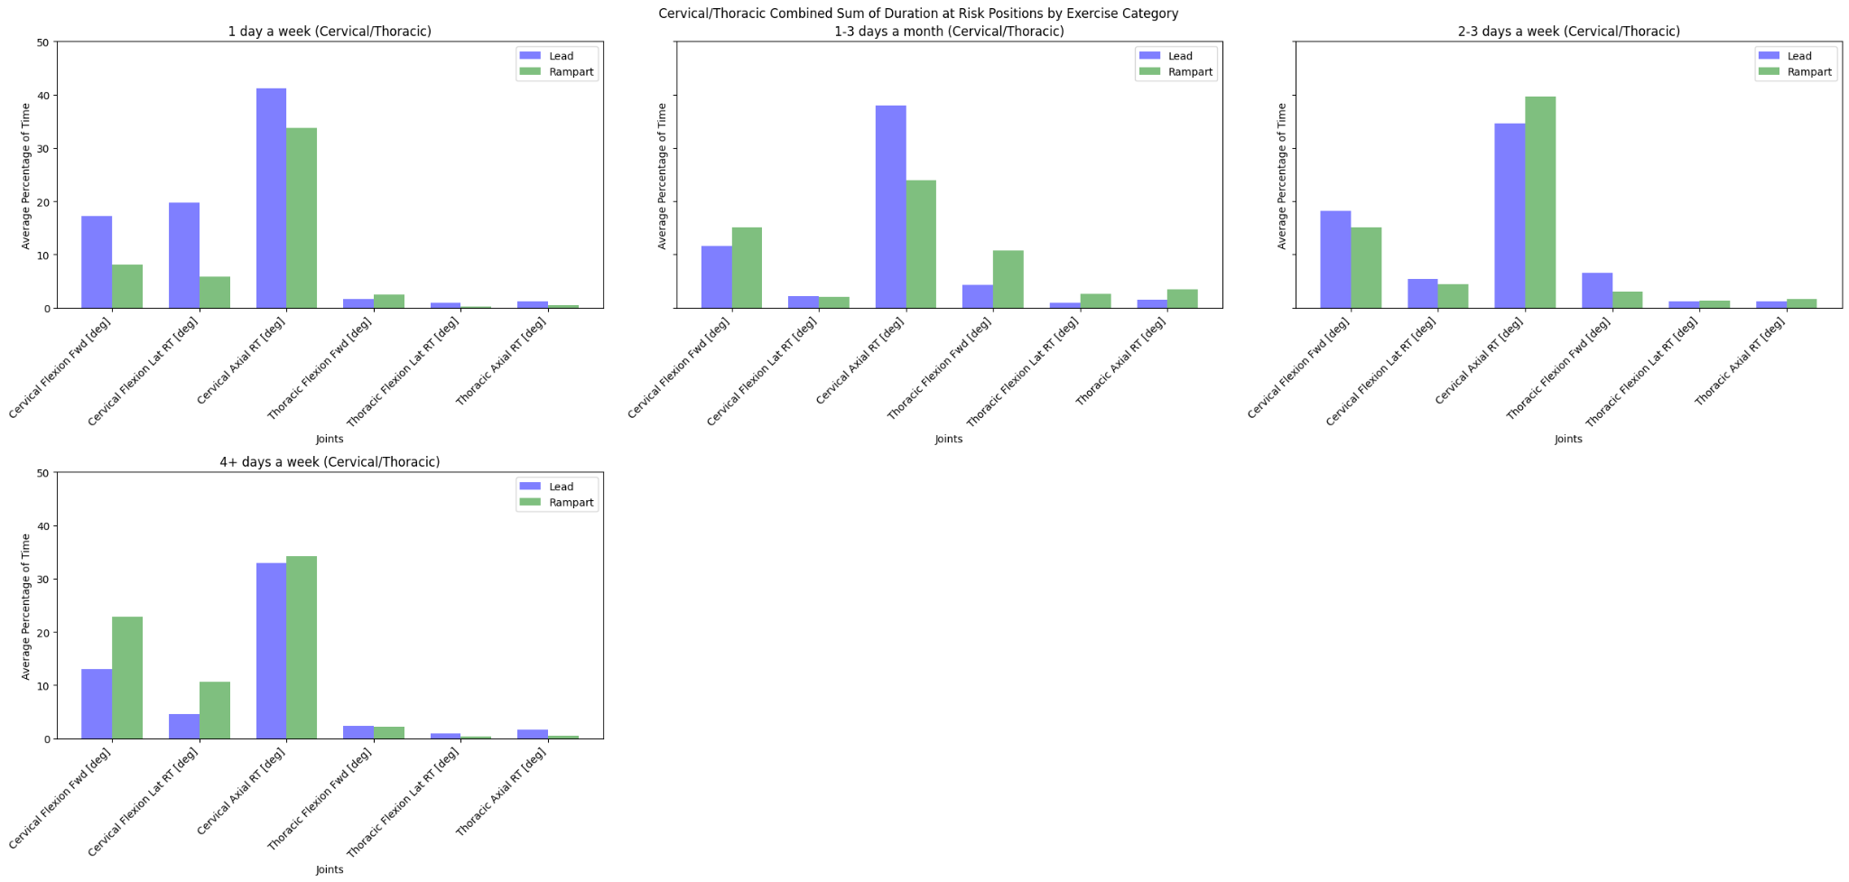
    - I may have gotten that the more you exercise the greater amount of time at risk threshold. That could be just more general movement that this person is willing to make.
    - Whether that is good or bad is interesting to look at.
  + 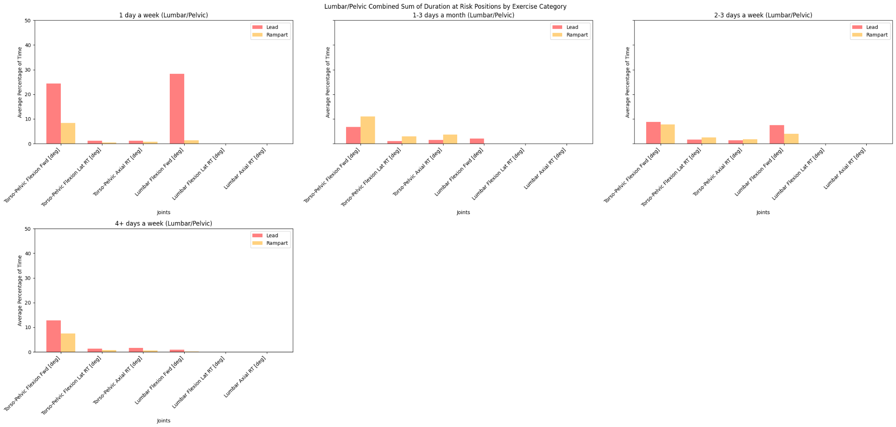
* Looking at time duration of surgeries:
  + 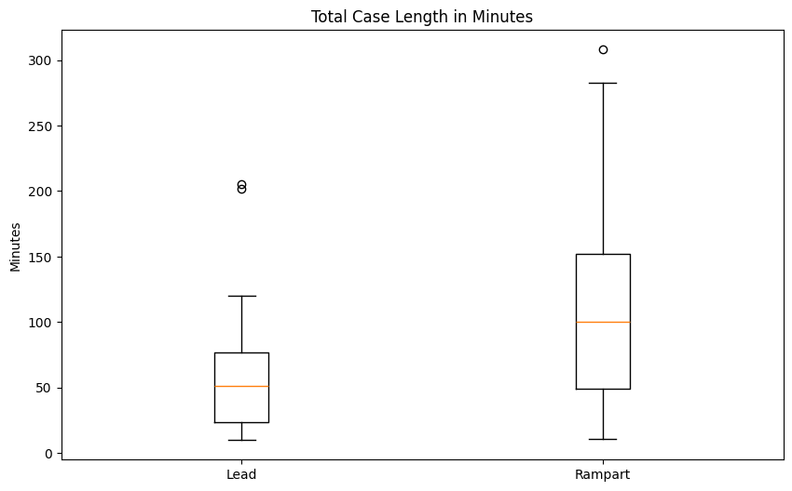
    - Immediately I noticed that there were discrepancies in the total case length for lead versus rampart. Rampart appeared to be used more when there was a longer case.
  + Stratification of time-based groups:
  + 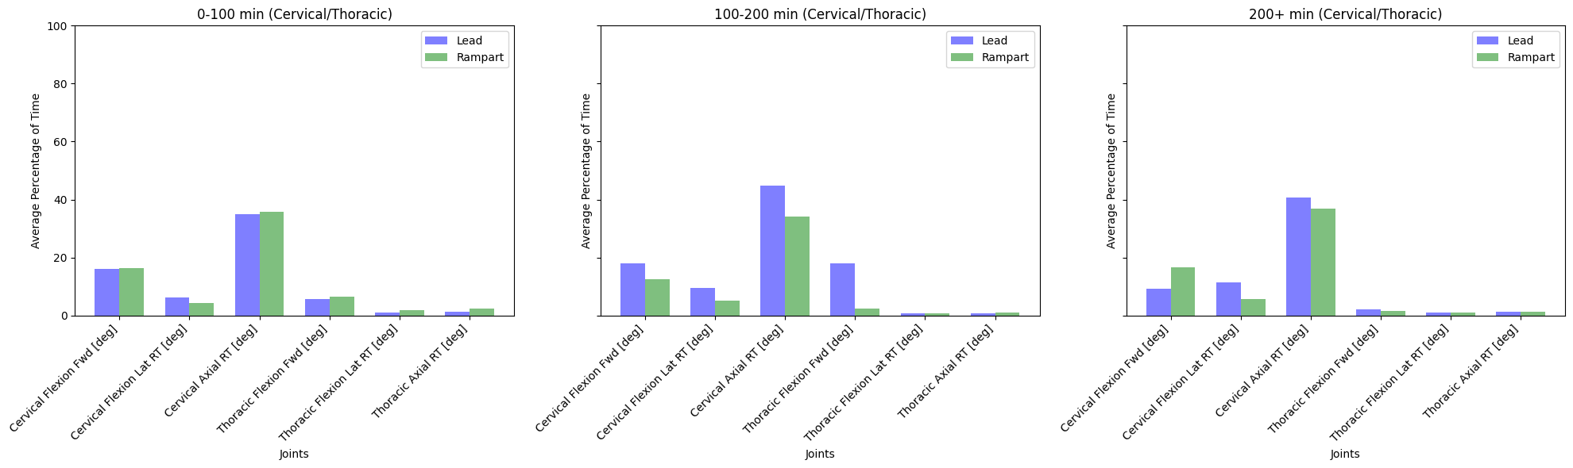
  + 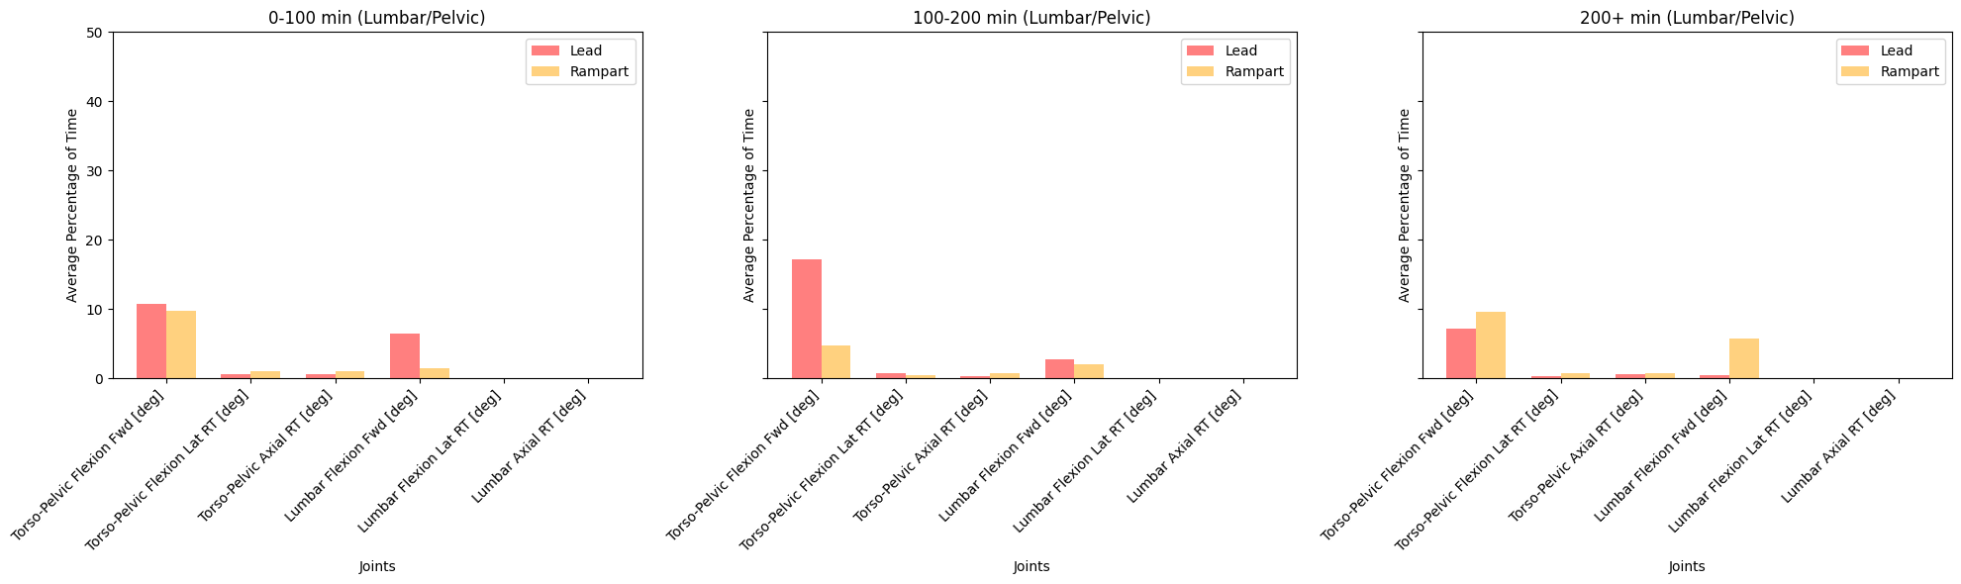
* Looking at BMI Classifications:
  + 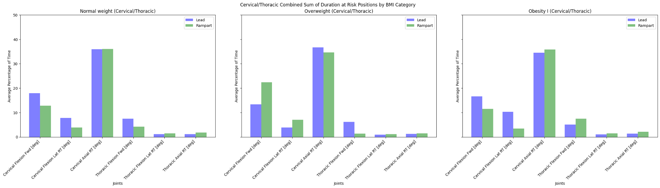
  + 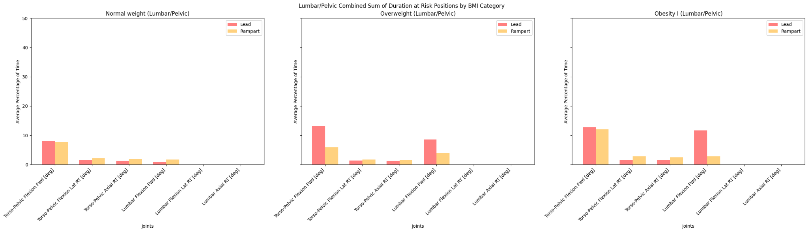

# Other Things to Address

* Dr. Hughes and I will come up with ideas for the main two or three plots and different ideas for figures to choose from in the coming days.
* Overall, I hope all the analysis so far is able to be used to give a better layout of how the data looks for the operators. Be sure to let me know of any ideas for future analysis that we haven’t discussed or a different way you want to visualize the data.